 | 12.1.14 Editors - Geometry Nodes Editor - Header - Add Menu - Mesh
Table of content
Detailed table of content 1
Add menu - Mesh 4
Dual Mesh 4
Mesh Boolean 5
Mesh to Curve 5
Mesh to Points 6
Split Edges 6
Subdivide Mesh 7
Subdivision Surface 7
Triangulate 8
Edge Angle 9
Edge Neighbours 9
Edge Vertices 10
Face Area 10
Face Neighbours 10
Mesh Island 11
Is Shade Smooth 11
Vertex Neighbors 11
Set Shade Smooth 12
Legacy - Mesh 12
Edge Split 12
Subdivision Surface 13

Detailed table of content
Detailed table of content
Detailed table of content 1
Add menu - Mesh 4
Dual Mesh 4
Inputs 4
Mesh 4
Keep Boundaries 4
Outputs 4
Dual Mesh 4
Mesh Boolean 5
Inputs 5
Geometry 1, 2 5
Self Intersect 5
Hole Tolerant 5
Properties 5
Operation 5
Intersect 5
Union 5
Difference 5
Output 5
Geometry 5
Mesh to Curve 5
Inputs 5
Mesh 5
Selection 6
Outputs 6
Curve 6
Mesh to Points 6
Inputs 6
Mesh 6
Selection 6
Position 6
Radius 6
Properties 6
Mode 6
Outputs 6
Curve 6
Split Edges 6
Inputs 7
Mesh 7
Selection 7
Outputs 7
Mesh 7
Subdivide Mesh 7
Inputs 7
Geometry 7
Level 7
Outputs 7
Geometry 7
Subdivision Surface 7
Inputs 7
Geometry 7
Level 8
Creases 8
Properties 8
UV Smooth 8
Boundary Smooth 8
Outputs 8
Geometry 8
Triangulate 8
Inputs 8
Geometry 8
Minimum Vertices 8
Properties 8
Quad Method 8
Beauty 9
Fixed 9
Fixed Alternate 9
Shortest Diagonal 9
Polygon Method 9
Beauty 9
Clip 9
Outputs 9
Geometry 9
Edge Angle 9
Outputs 9
Angle 9
Edge Neighbours 9
Outputs 10
Face Count 10
Edge Vertices 10
Outputs 10
Vertex Index 1 10
Vertex Index 2 10
Position 1 10
Position 2 10
Face Area 10
Outputs 10
Area 10
Face Neighbours 10
Outputs 11
Vertex Count 11
Face Count 11
Mesh Island 11
Outputs 11
Index 11
Is Shade Smooth 11
Outputs 11
Smooth 11
Vertex Neighbors 11
Outputs 11
Vertex Count 11
Face Count 11
Set Shade Smooth 12
Input 12
Geometry 12
Selection 12
Shade Smooth 12
Outputs 12
Geometry 12
Legacy - Mesh 12
Edge Split 12
Inputs 12
Geometry 12
Edge Angle 12
Angle 12
Sharp Edges 13
Outputs 13
Geometry 13
Subdivision Surface 13
Inputs 13
Geometry 13
Level 13
Creases 13
Properties 13
UV Smooth 13
Boundary Smooth 13
Outputs 13
Geometry 13

Add menu - Mesh
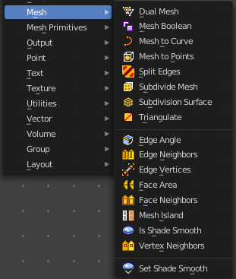
Nodes to modify the mesh geometry.

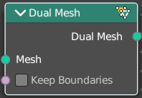
Dual Mesh
The Dual Mesh node calculates the dual of the input mesh. This means that faces get replaced with vertices and vertices with faces.

Inputs

Mesh
The input mesh.

Keep Boundaries
Keep the (non-manifold) boundaries of the mesh intact.

Outputs

Dual Mesh
The output mesh.

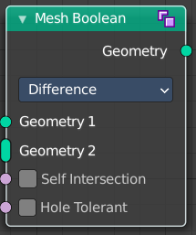
Mesh Boolean
The Boolean Node allows you to cut, subtract, and join the geometry of two inputs. This node offers the same operations as the Boolean modifier.

Inputs

Geometry 1, 2
Standard geometry input.

Self Intersect
Allow self intersection.

Hole Tolerant
Allow holes.

Properties

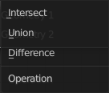
Operation
The boolean operation.

Intersect
Produce a new geometry containing only the volume inside of both geometry 1 and geometry 2.

Union
The two input pieces of geometry are joined, then any interior elements are removed.

Difference
Geometry 2 is subtracted from geometry 1 (everything outside of geometry 2 is kept).

Output

Geometry
Standard geometry output.

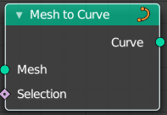
Mesh to Curve
Converts a mesh geometry to a curve geometry.

Inputs

Mesh
Input mesh.

Selection
A selection of the input mesh.

Outputs

Curve
Standard curve output.

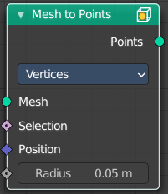
Mesh to Points
Converts a mesh geometry to a point geometry.

Inputs

Mesh
Input mesh.

Selection
A selection of the input mesh.

Position
The position of the points.

Radius
The radius of the points

Properties

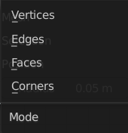
Mode
What geometry to convert to points.

Outputs

Curve
Standard curve output.

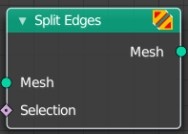
Split Edges
Splits the edges of the geometry.
Note that splitting edges breaks the mesh topology.

Inputs

Mesh
Input mesh.

Selection
A selection of the input mesh.

Outputs

Mesh
Standard Mesh output.

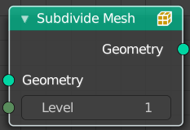
Subdivide Mesh
Subdivides the geometry by a simple division.

Inputs

Geometry
Standard geometry input.

Level
To which degree the geometry will be deformed.

Outputs

Geometry
Standard geometry output.

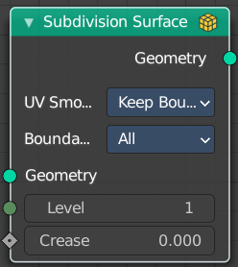
Subdivision Surface
The Subdivision Surface node subdivides the geometry using Catmull-Clark deformation.

Inputs

Geometry
Standard geometry input.

Level
To which degree the geometry will be deformed.

Creases
Control how smooth edges should be with Weighted Edge Creases.

Properties

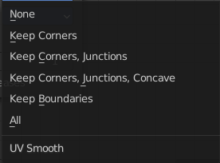
UV Smooth
The methbod to deal with smoothing the UV.

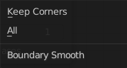
Boundary Smooth
Controls if open boundaries and corners are smooth.

Outputs

Geometry
Standard geometry output.

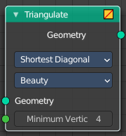
Triangulate
The Triangulate node triangulates all faces in a mesh.

Inputs

Geometry
Standard geometry input.

Minimum Vertices
Minimum number of vertices a face must have to be triangulated. For example, setting this value to 5, will prevent triangulation of Quads and only triangulate N-gons.

Properties

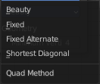
Quad Method
A quad is a polygon with four edges.

Beauty
Split the quads in nice triangles, slower method.

Fixed
Split the quads on their 1st and 3rd vertices.

Fixed Alternate
Split the quads on their 2nd and 4th vertices.

Shortest Diagonal
Split the quads based on the diagonal distance between their vertices.

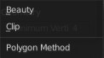
Polygon Method
Meant are N-Gons. Faces with more than four edges. Tris, Quads and N-Gons are all Polygons.

Beauty
Arrange the new triangles nicely, slower method.

Clip
Split the polygons using an ear-clipping algorithm (gives similar results to the tessellation used for the viewport rendering).

Outputs

Geometry
Standard geometry output.

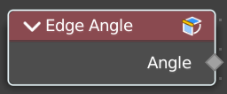
Edge Angle
Calculates the angle in radians between two faces that meet at an edge. Without two faces on the edge, the angle will be 0.

Outputs

Angle
The output angle.

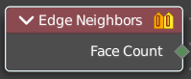
Edge Neighbours
Outputs the number of faces connected to each edge.

Outputs

Face Count
The number of faces.

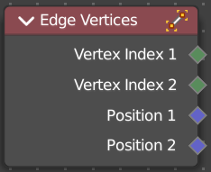
Edge Vertices
Outputs the index and position of the two vertices that defines an edge. Index outputs an integer. Position a vector.

Outputs

Vertex Index 1
The index of the first vertice.

Vertex Index 2
The index of the second vertice.

Position 1
The position of the first vertice.

Position 2
The position of the second vertice.

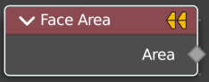
Face Area
Gives each face area a unique id. Which can be used in a capture attribute for example, to create instances of other geometry to this now unique face areas.

Outputs

Area
The face area output.

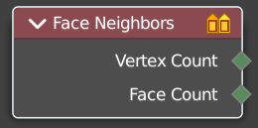
Face Neighbours
Outputs the number of vertices or faces connected to each face.

Outputs

Vertex Count
The vertex count for the face neighbors.

Face Count
The face count for the face neighbors.

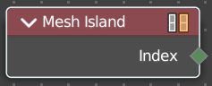
Mesh Island
Outputs a separate index for each mesh island. The indices are based on the order of the lowest-numbered vertex in each island.

Outputs

Index
The index output.

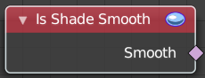
Is Shade Smooth
Retreives if the geometry is shaded smooth.

Outputs

Smooth
Smooth output.

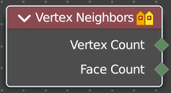
Vertex Neighbors
Outputs the number of vertices or faces connected to each vertex.

Outputs

Vertex Count
The vertex count for the vertex neighbors.

Face Count
The face count for the vertex neighbors.

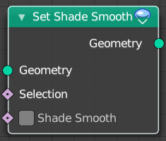
Set Shade Smooth
Retreives if the geometry is shaded smooth.

Input

Geometry
Input mesh.

Selection
A selection of the input mesh.

Shade Smooth
Set the shading to smooth.

Outputs

Geometry
Geometry output.

Legacy - Mesh

These nodes existed in a former Bforartists version, but are now deprecated. They do not show in the regular menu or UI anymore. And you cannot insert them in a newer Bforartists version. But old projects that uses this nodes still loads with these nodes showing and enabled.

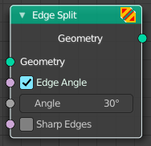
Edge Split
The Edge Split node splits as split edge marked edges into two edges.
Note that splitting edges breaks the mesh topology.

Inputs

Geometry
Standard geometry input.

Edge Angle
When enabled, edges will be split if the angle between its two adjacent faces is greater than the Split Angle.

Angle
On 0: all edges are split. On 180: no edges are split.

Sharp Edges
When enabled, edges will be split if they were marked as sharp.

Outputs

Geometry
Standard geometry output.

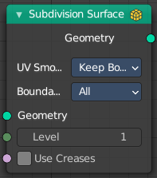
Subdivision Surface
The Subdivision Surface node subdivides the geometry using Catmull-Clark deformation.

Inputs

Geometry
Standard geometry input.

Level
To which degree the geometry will be deformed.

Creases
Control how smooth edges should be with Weighted Edge Creases.

Properties

UV Smooth
The methbod to deal with smoothing the UV.

Boundary Smooth
Controls if open boundaries and corners are smooth.

Outputs

Geometry
Standard geometry output.

